**E-Commerce Website Project for Women’s Clothing**

**Project Title:**

Chic Sphere

**Mission Statement:**

Our mission is to offer affordable, loved styles that empower women of all ages. We believe in accessible fashion that doesn't compromise on quality.  
“To celebrate women of all backgrounds by offering stylish, affordable clothing that blends timeless design with cultural influences. We empower confidence through accessible fashion that inspires self-expression.”

**Who will benefit other than the owner?**

* Customers
* Team Members
* Manufacturer / Supplier
* Marketing personnel

**What makes it a good idea (Motivation)?**

Market Demand and E-commerce growth are the sole factors to go for this project. Choosing to start an online dress-selling business makes sense because lots of people prefer to shop online nowadays. The website of Chic Sphere is coming up to provide a service of customized style and personalized recommendation according to the customer’s demand. Plus, it's something I'm really interested in. So, it's like hitting two birds with one stone – meeting what people want and doing something I love.  
Combining these factors – market demand, addressing a customer need, and your own interest – creates a strong foundation for a successful online clothing business.

**Where?**

Initially, Chic Sphere will serve nationwide, across Pakistan. Also, we aim to serve internationally in future.

**Architecture Used:**

Client-Server architecture is followed by Chic Sphere.

**Technologies Used:**

Frontend: HTML, CSS, JavaScript (Client-side)

Backend: PHP, MySQL (Server-side)

**OOP concept used: Reusability.**

The basic concept of OOP is reusability. Some parts of code are reused multiple times like navbar, footer, product boxes. Code is read once for each of these and used again and again in different pages.

**SE concept used: Separation of Concerns**

MVC architecture is used to maintain important principle of software engineering. This is a 3-tiered architecture.

* Model: business/logic layer
* View: Presentation layer
* Control: Backend with DB

Separate files are made for all these three purposes.

* HTML/CSS for presentation layer
* JavaScript for business layer
* PHP for backend connected with database.

**Benefits of this Modularity:**

* **Maintainability:** Changes to the website's design (CSS) wouldn't affect the underlying functionalities (PHP scripts).
* **Reusability:** Reusable templates like navbar.html can be incorporated into different pages, reducing code duplication.
* **Readability:** A clear separation promotes cleaner and more readable code for both presentation and logic.

**DBS concept used:**

MySQL is used to make connections with database. Database tables are maintained in phpMyAdmin through xampp server.

if ($_SERVER["REQUEST_METHOD"] == "POST") {

    $name = $_POST["name"];

    $email = $_POST["email"];

    $phone = $_POST["phone"];

    $address = $_POST["address"];

    $sql = "INSERT INTO orders (name, email, phone, address)

            VALUES ('$name', '$email', '$phone', '$address')";

    if ($conn->query($sql) === TRUE) {

        echo "New record created successfully";

    } else {

        echo "Error: " . $sql . "<br>" . $conn->error;

    }

**Security**

We take the security of your information very seriously at Chic Sphere. Here's how we protect user’s data:

* **Hashed Passwords:** When you create an account, your password is never stored in plain text. Instead, it undergoes a hashing function that creates a unique, unreadable string. This means even if someone were to gain access to our database, they wouldn't be able to decrypt your password even if the database is compromised.

**Class Diagram:**

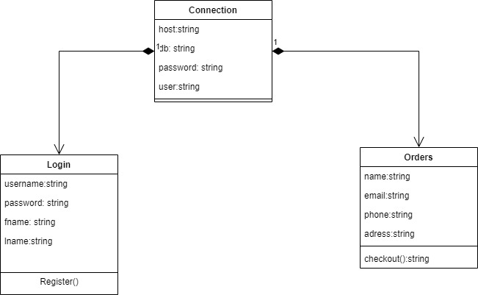

**Entity Relationship Diagram:**

